**Set up a common date table**

**Introduction**

In this lesson, you’ve explored the significance of a common-date table in a data model. You’ve also reviewed the process for creating a common-date table in your models using both DAX and M language in Power BI

In this exercise, you must apply your knowledge of DAX and Power Query to generate a date dimension table within a data model.

* You’ll walk through the steps to create a date dimension table using DAX in Power BI.
* The goal is understanding how Power BI allows you to control your data model according to your analytical needs.

**Case study**

Adventure Works collects data from a range of different sources and collates this data in a data model that contains the following tables:

* **Sales**
* **Salesperson**
* **Products**
* **Reseller**
* And **Region**

However, there’s no date dimension table in these datasets. This makes it difficult to perform time intelligence analysis. Help Adventure Works to create a common-date table in its data model using DAX.

**Step 1: Download and launch the Power BI project file AdventureWorks.pbix.**

* Adventure Works provides a Power BI project file called **AdventureWorks.pbix**. that contains the required data model. You must download this dataset and load it into Power BI.

**Step 2: Observe the data model and create a date dimension table using DAX.**

1. Access the **Model** tab in Power BI to view the data model’s tables. Note that there is no date dimension table present.

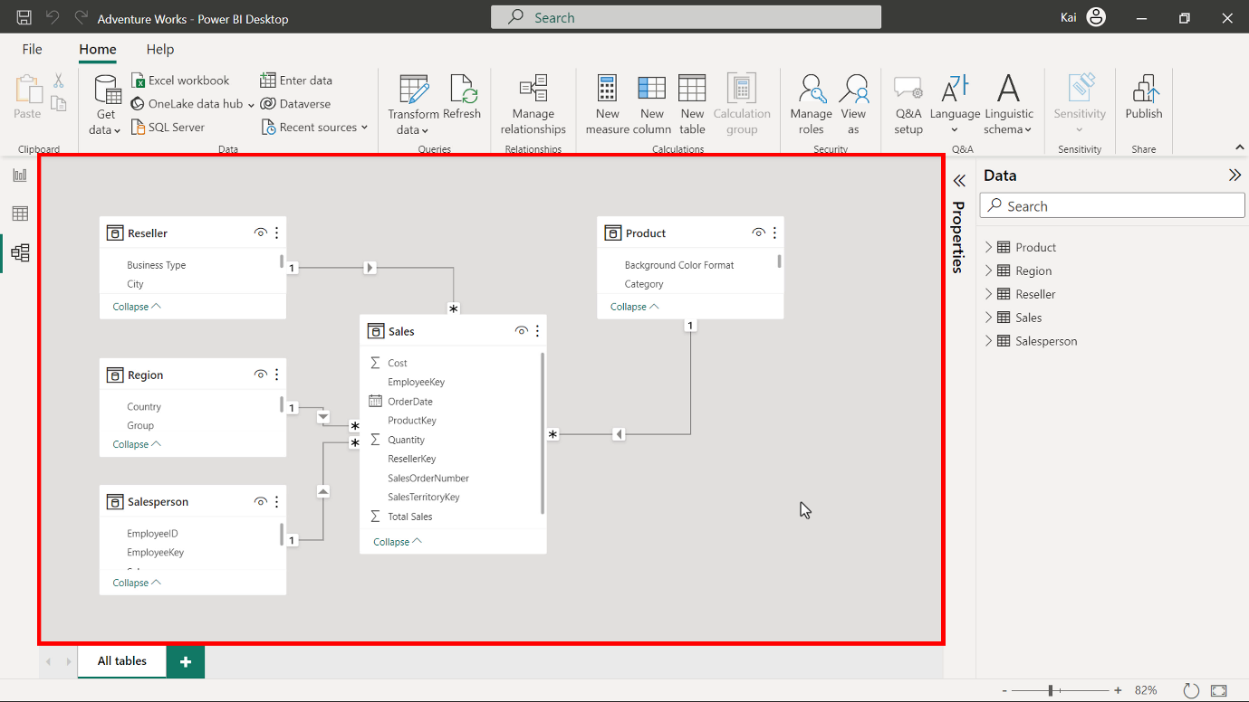

1. Navigate to the **Home** tab and select **New**table from the calculations group. In the formula bar, input the following DAX code using the **CALENDAR** function to create a table with a single column containing dates.

1

Date = CALENDAR ( DATE( 2017, 1, 1 ), DATE ( 2021, 12, 31 ))

In the **CALENDAR** function, you need to specify the start and end dates. The Adventure Works sales data starts in 2017 and ends in 2020. The start date must occur on or before the date column of the dataset. The end date must be on or after the end date of the dataset. Execute the code to generate a table with a single date column containing a list of dates with time.

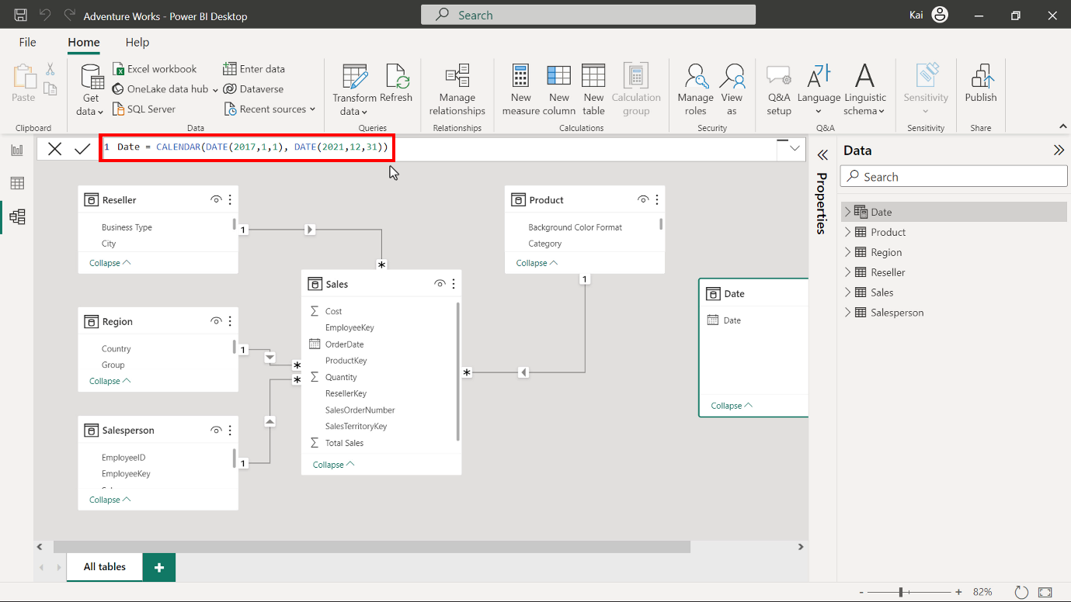

1. Now you must format and configure the table. Rename the column as **Date** and format the column as **Date** data type. Select the **Date** column and navigate to the **Column tool** tab.

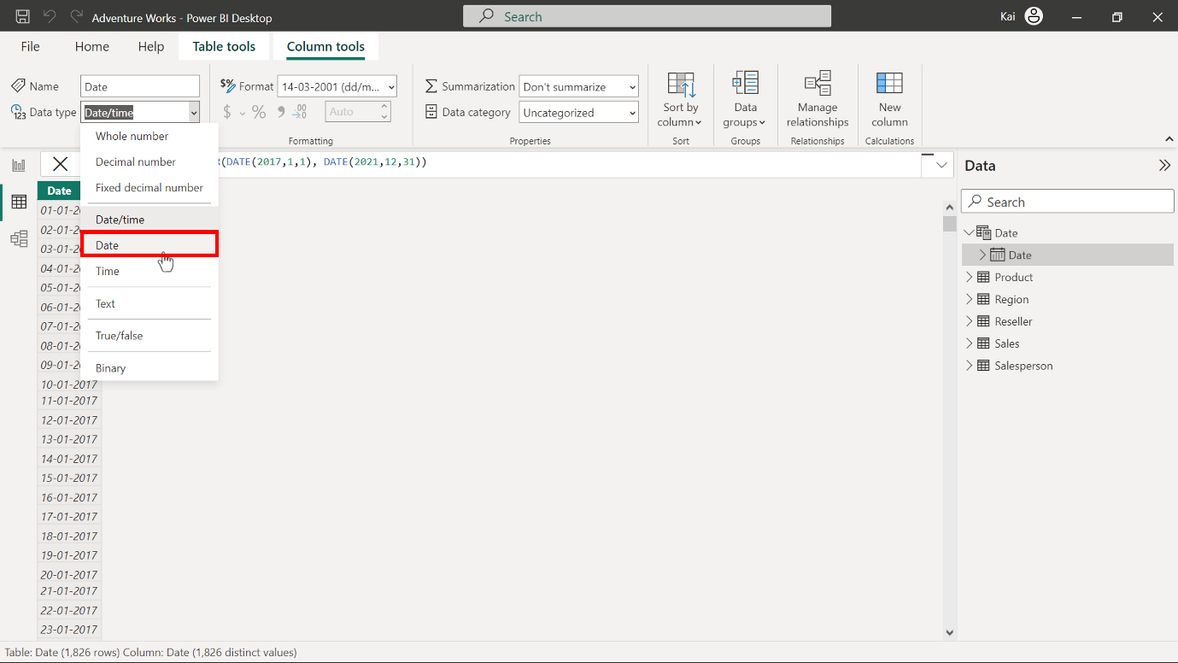

Select the appropriate date format from the format drop-down list of options.

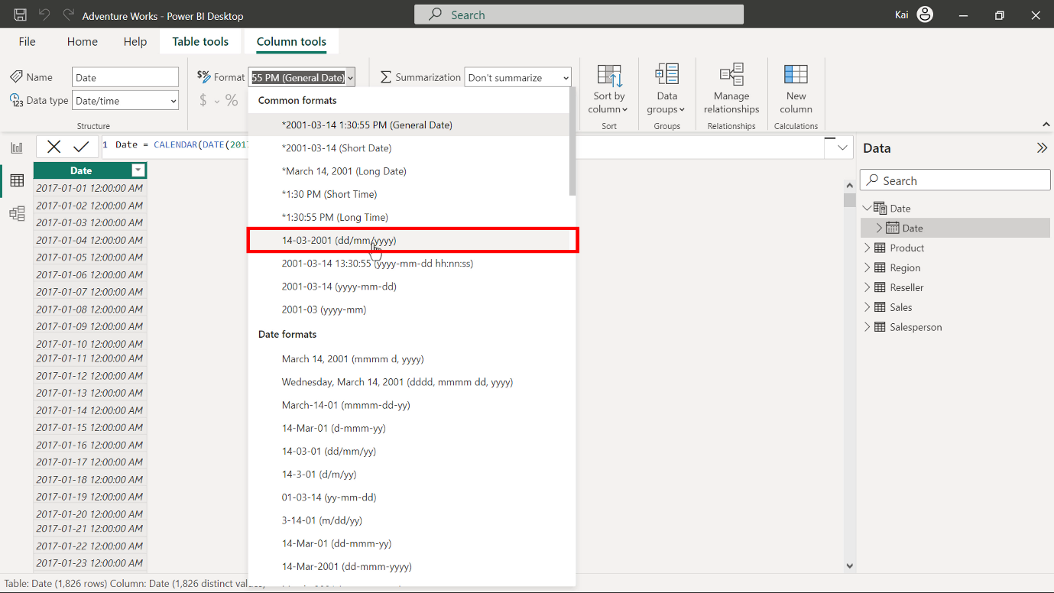

1. Next, you must populate the date dimension table with related columns like **year**, **month number**, **month**, **day of the week**, and **week number**. Select **New column** from the **Calculations** group of the **Column tools** tab to expand the DAX formula bar. Then enter the following DAX codes, one in each step.

Year = YEAR ( 'Date'[Date] )

Month = FORMAT ( 'Date'[Date], "MMMM" )

Month Number = MONTH ( 'Date'[Date] )

Day of the Week = FORMAT ( WEEKDAY( 'Date'[Date] ), "dddd" )

Week Number = WEEKNUM ( 'Date'[Date]

* The date-related functions in the above DAX formulas, like **YEAR**, **MONTH**, **WEEKNUM**, **WEEKDAY** extract the relevant information from the date column of the table.

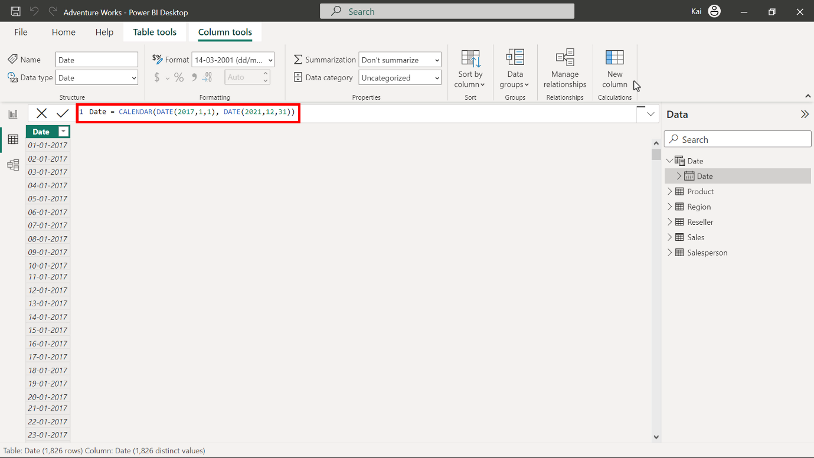

Copy and paste the following code into the formula bar to add the **YEAR** data.

1

Year =  YEAR ( 'Date'[Date] )

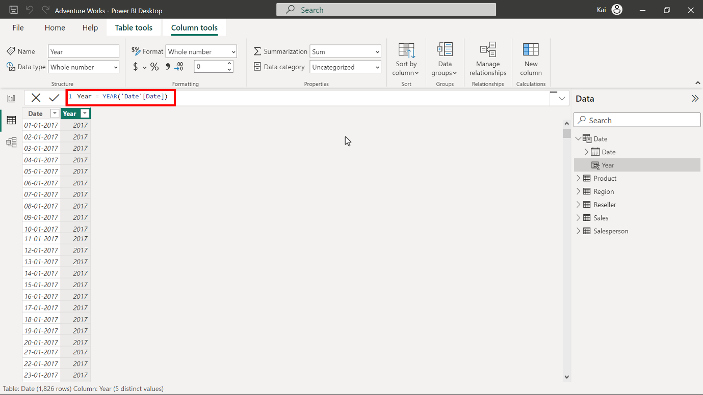

Copy and paste the following code into the formula bar to add the **MONTH** data.

1

Month = FORMAT ( 'Date'[Date], "MMMM" )

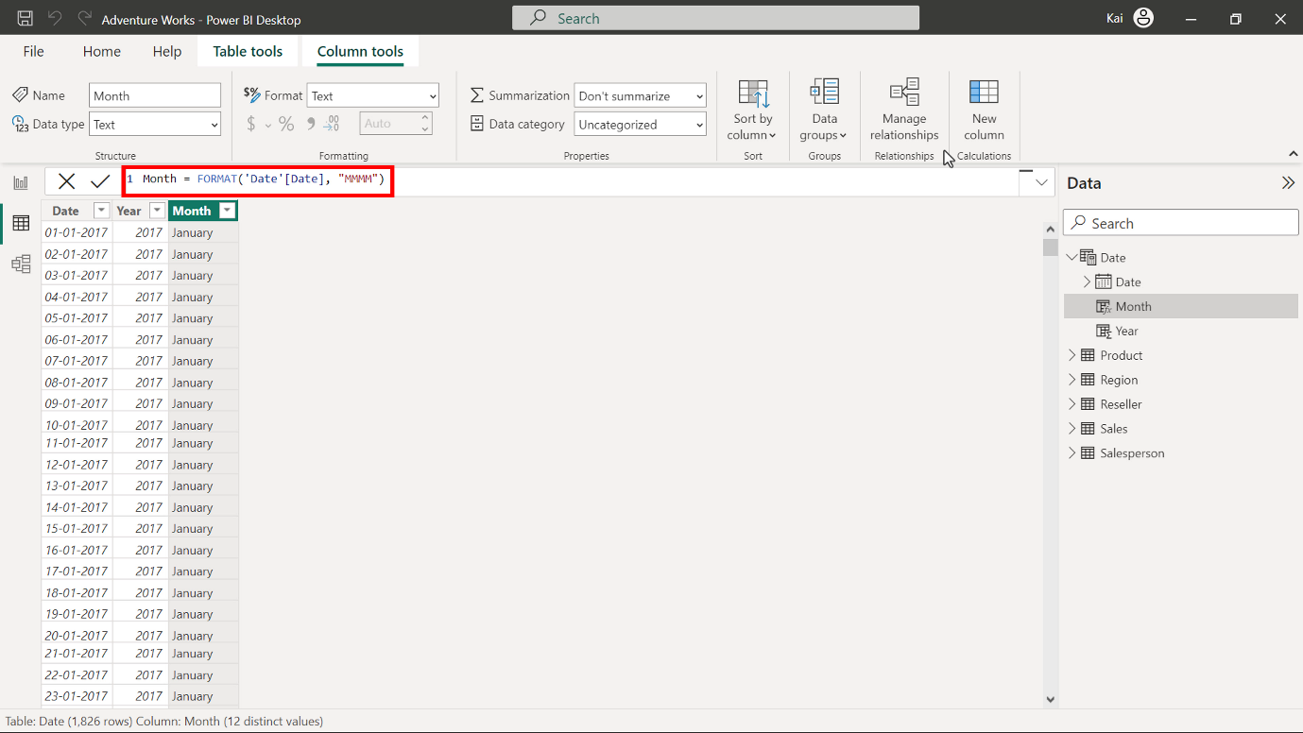

Copy and paste the following code into the formula bar to add the **DAY OF THE WEEK** data.

1

Day of the Week = FORMAT ( WEEKDAY( 'Date'[Date] ), "dddd" )

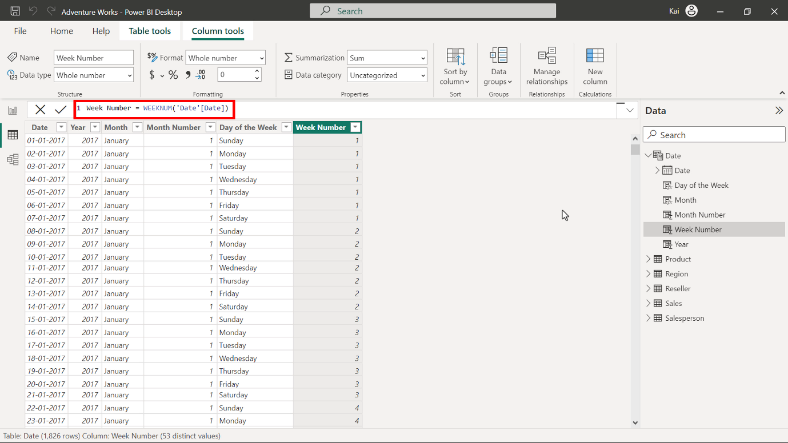

1. Next, mark the newly created **date** dimension table as a date table. Select the ellipses on the right side of the date table and select **Mark as date table** from the drop-down list of options. This opens a dialog box that states **Mark as date table**.

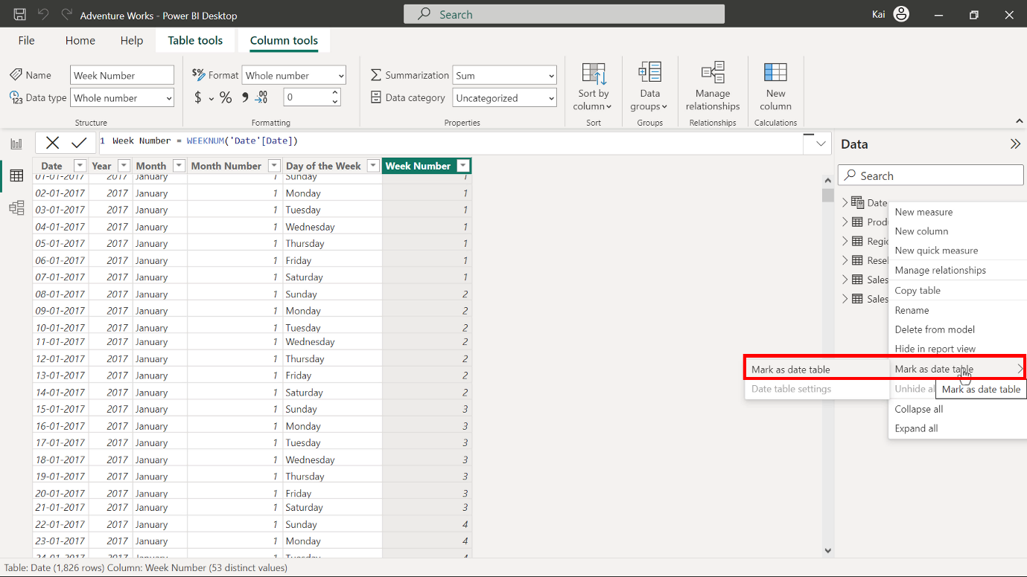

Select the **Date** option from the **Date** column drop-down menu. Once you select the date column, it displays a message **Validate successfully**. Select **OK**.

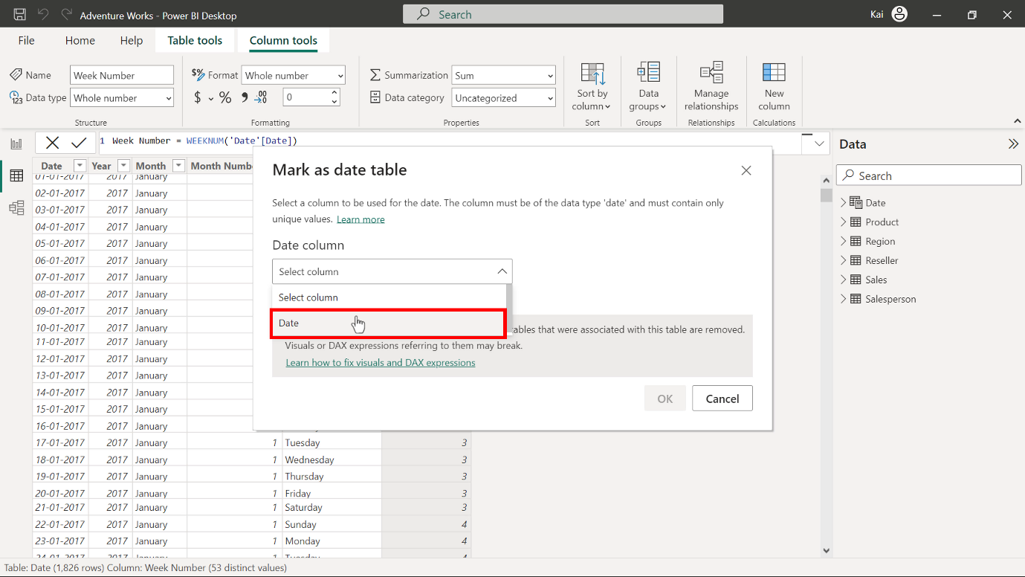

1. Next, you must establish a relationship between the **Date** and the **Fact** table in the data model. A **Date** dimension table is ready for analysis and reporting in your data model.

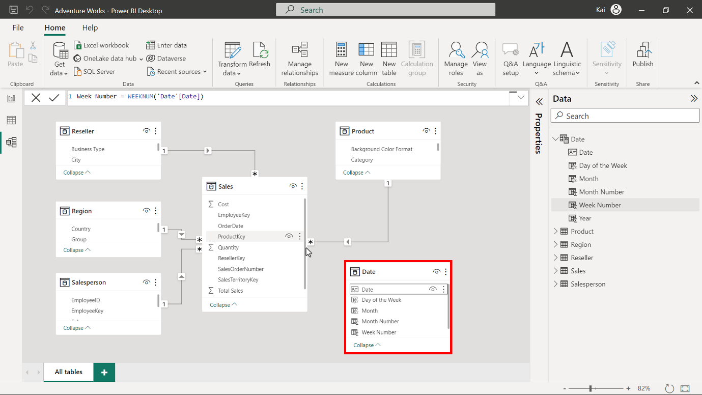

**Step 4: Save the project.**